LINUX PROGRAMMING -SWE4009
LAB ASSIGNMENT -DEBUGGING
ANJANA P
17MIS1028

1.) CODE:
#include <stdio.h>
/* Print the sum of the integers from 1 to 1000 */
int main(int argc, char **argv)
{
int i;
int sum;
sum = 0;
for(i = 0; i -= 1000; i++)
{ sum += i; }
printf("%d\n", sum);
return 0;
}

SCREENSHOT:

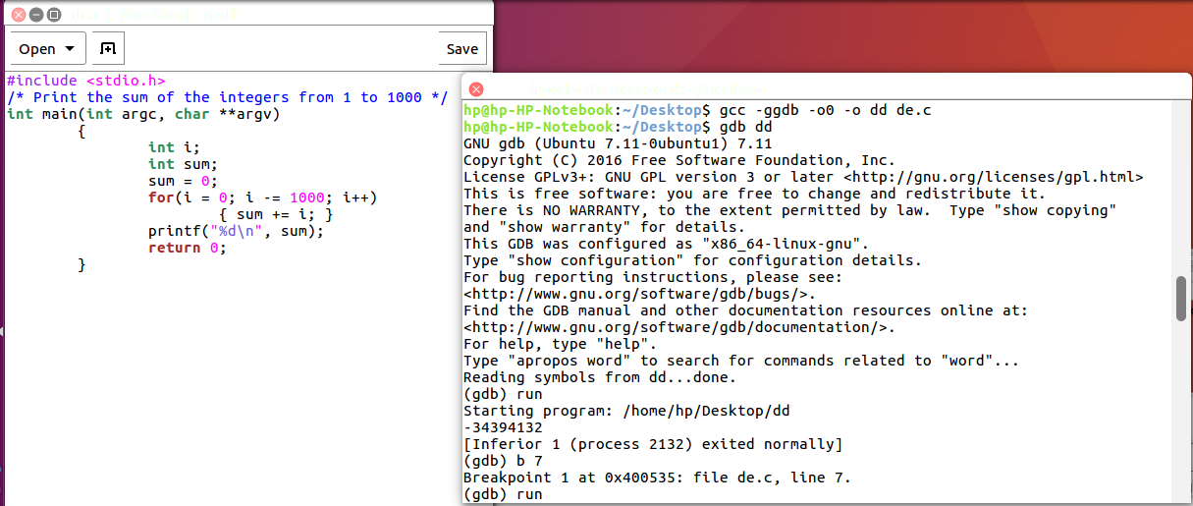

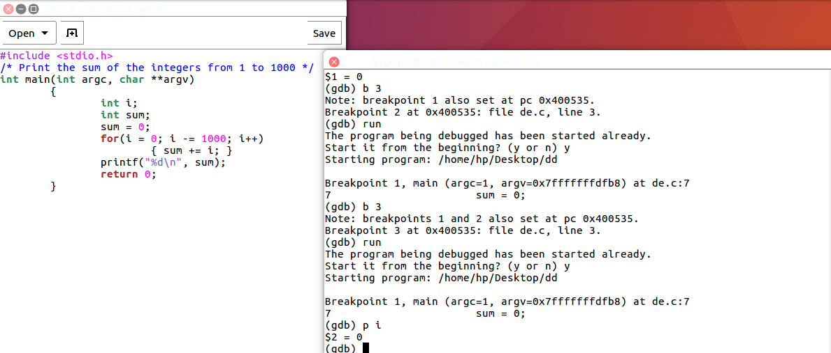
ERROR: found in for loop (line number 7)

2,) CODE:

#include <stdio.h>
int main()
{
char *s = "goal";
char *t = "home";
while(*s++ == *t++)
printf(*s);
return 0;
}

SCREENSHOT:

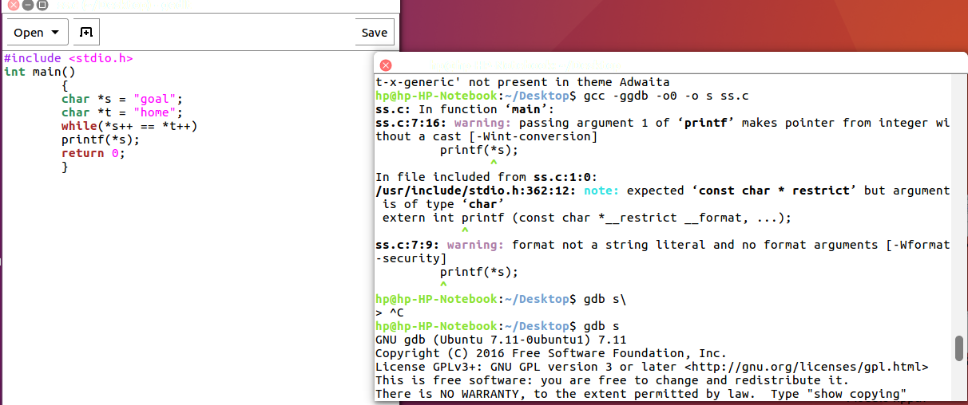

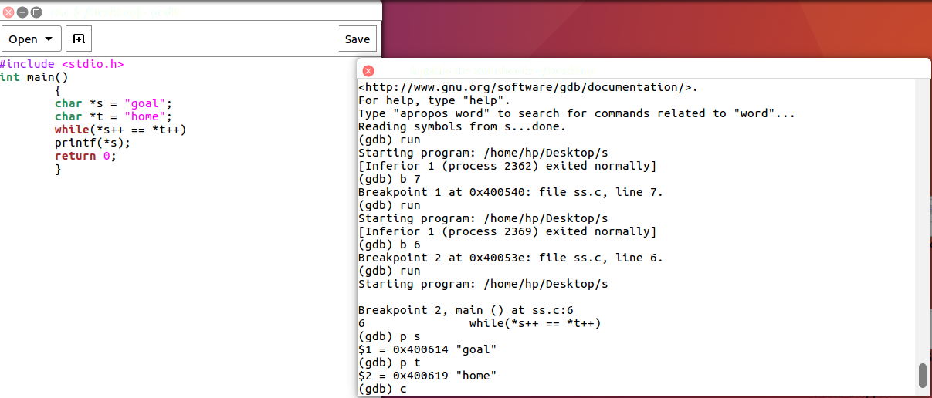

ERROR: found in while loop( line number 6).

